Swavy Fix – How to Use
Find a verified artisan in Lagos or Abuja and agree the price before they come.

What it does
- Book in 3 taps: service → problem → area. See verified artisans with ratings, jobs done, starting price and reply time.
- Fixed price first: the artisan quotes labour + parts; you tap Accept & lock.
- No surprise charges: any new price needs a reason and your approval.
- Tracking: Requested → Quote sent → Accepted → On the way → Working → Done, with photos.
- Completion code: the job only finishes when you give the artisan your 4-digit code. Only code-confirmed jobs can be reviewed.
- Artisan dashboard, price guide, admin page, WhatsApp buttons, light/dark mode, installable as an app.
- Services: plumbers, electricians, AC and generator repair, carpenters, painters, tilers, mechanics, cleaners, hair & makeup.

How to open it on Windows
1. Open the swavy-fix folder.
2. Double-click start.bat.
3. Your browser opens http://localhost:3000 (next free port if busy).
4. Keep the black window open.

Demo logins (password for all: swavy123)
Who | Email | What to try
Customer (Lekki) | customer@swavy.ng | Quote waiting to accept, and a finished job
Customer (Wuse) | customer2@swavy.ng | A second customer
Plumber, Lagos | artisan@swavy.ng | 2 new requests to price
Electrician, Lagos | artisan2@swavy.ng
AC repair, Abuja | artisan3@swavy.ng | A locked job to start

Admin page: http://localhost:3000/#/admin – password swavyadmin. Change it with ADMIN_PASSWORD=... in a .env file.

Step by step

Customer: book and lock a price
1. Log in as customer@swavy.ng.
2. Tap a service tile, tap the problem (or type it and add a photo), tap your area.
3. Choose an artisan.
4. When the quote arrives, check it and tap Accept & lock.
5. When you are happy with the work, give the artisan your 4-digit code. Then pay them directly and leave a review.
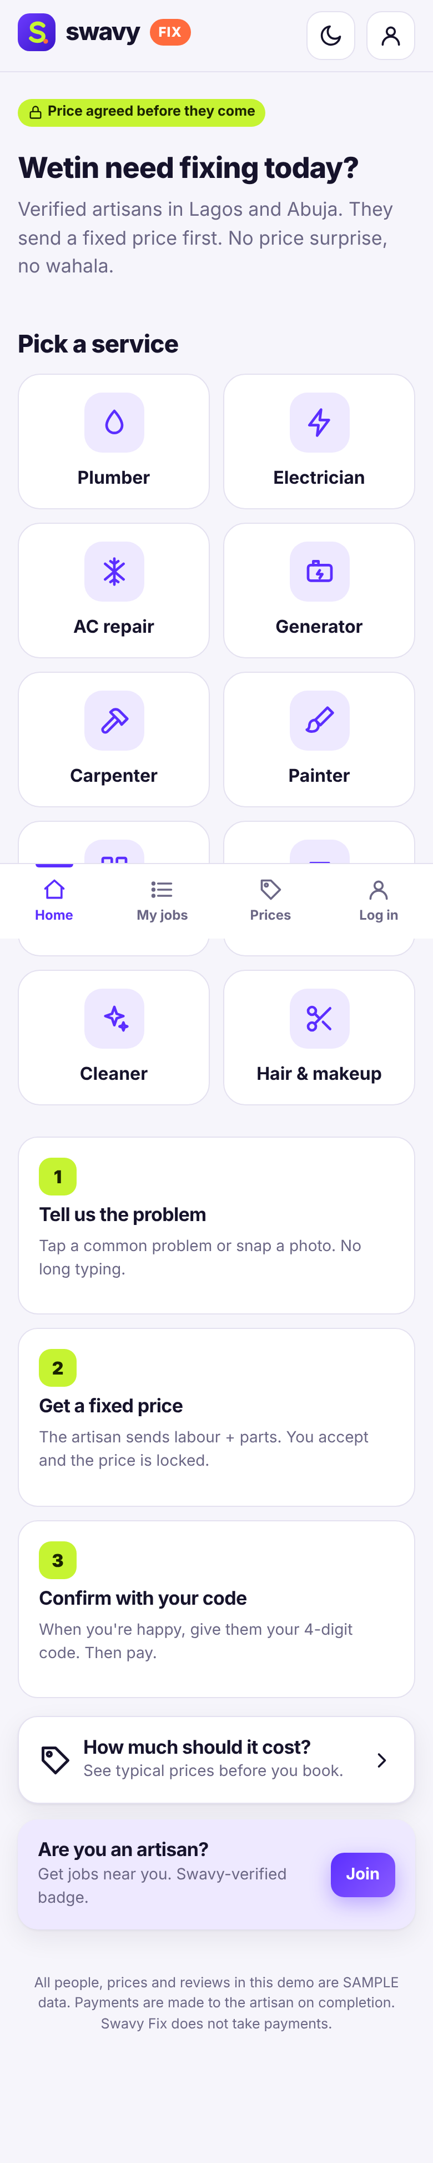
Customer home
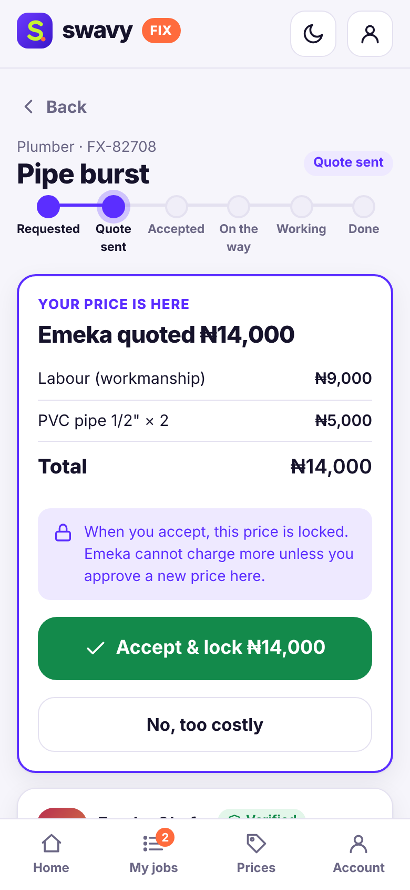
A quote ready to accept and lock

Artisan: send a quote
1. Log in as artisan@swavy.ng.
2. Open a new request.
3. Add labour and parts in the quote builder and send.
4. If you need more parts later, send a new price with a reason – it waits for the customer.
5. Enter the customer's code to finish the job.
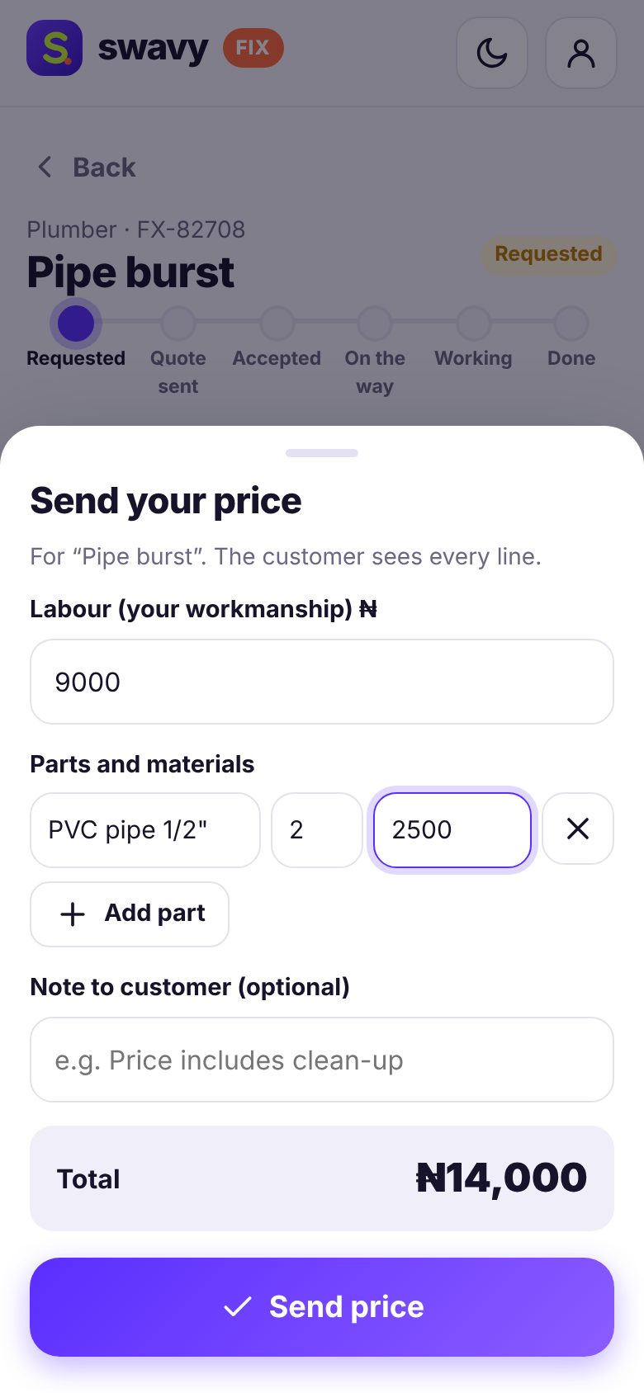
The artisan quote builder

Your data and the database
Everything is saved in one file: data\swavy-fix.db inside the Swavy Fix folder. It is created the first time you start the app.

Look inside
- Open a Command Prompt in the folder (click the address bar in File Explorer, type cmd, press Enter) and type npm run db to list every table and how many rows it has.
- Type npm run db -- jobs to see the latest rows of one table.
- Or install the free DB Browser for SQLite (https://sqlitebrowser.org) and open the .db file. Stop the app first.

Start fresh (reset)
1. Close the black window to stop the app.
2. Delete the data folder inside the project folder.
3. Double-click start.bat again. The sample data is created again.

Troubleshooting
Problem | What to do
The black window says "Node.js ... was not found" | Install Node.js 24 LTS from https://nodejs.org, restart the computer, then double-click start.bat again.
Port 3000 is busy / another app is open | Close the other black window (or the other app) and try again. The app tries the next free port automatically – read the address printed in the black window and type it into your browser.
The browser did not open | Open Chrome or Edge yourself and go to http://localhost:3000 (or the address shown in the black window).
The page will not load | Make sure the black window is still open. Closing it stops the app.
Windows SmartScreen / firewall warning | Click "More info → Run anyway" for start.bat. If asked about the firewall, choose Private networks.
Running with Flowboard or Oja | They also use port 3000. Close them first, or use the new address shown in the black window.

Honest limitations
- Swavy Fix does not take payments – the customer pays the artisan directly. In-app payments would need a provider like Paystack.
- All people, prices, reviews and photos are sample data; the price guide figures are samples.
- WhatsApp buttons only open a ready message – you press send.

